Network Security Groups
- Designed to filter traffic to (inbound) and from (outbound) Azure resources located in - Azure Virtual Network
- Filtering controlled by rules
- Ability to have multiple inbound and outbound rules
- Rules are created by specifying
  - Source/Destination (IP addresses, service tags, application security groups)
  - Protocol (TCP, UDP, any)
  - Port (or Port Ranges, ex. 3389 – RDP, 22 – SSH, 80 HTTP, 443 HTTPS)
  - Direction (inbound or outbound)
  - Priority (order of evaluation)
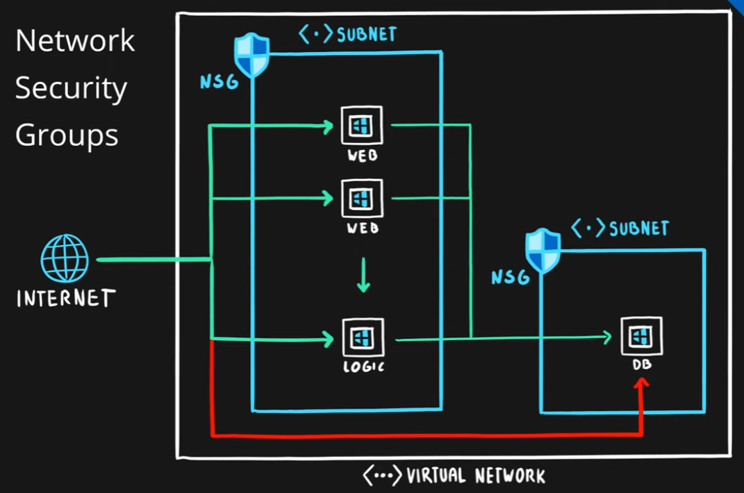

Application Security Groups
- Feature that allows grouping of virtual machines located in Azure virtual network
- Designed to reduce the maintenance effort (assign ASG instead of the explicit IP address)
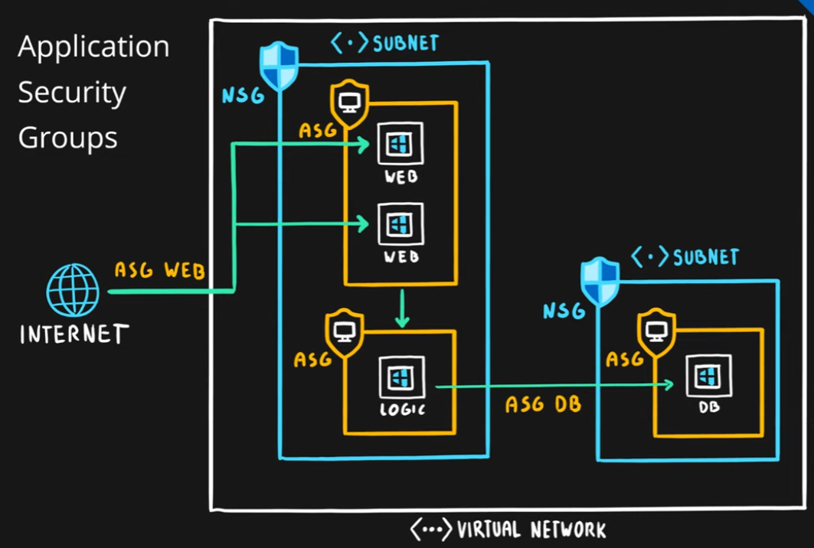

Summary
